**LEBANESE AMERICAN UNIVERSITY**

**USAID – HIGHER EDUCATION SCHOLARSHIP PROGRAM**

**HES - Volunteering Program Verification Form**

This form is to be used to document volunteering hours. If a student volunteers for multiple organizations, a separate form must be used for each organization. **This form must be turned in by the 28th of each month, the latest.**

I certify that the scholar Adam Abbas completed a total of 15 hours of service at InnovaThrive.

The hours were completed hours as per the below:

Hours # 0 (date) _2/12 – 6/12_ (initials of supervisor) __A.K.___

Hours # 5 (date) _9/12 – 13/12_ (initials of supervisor) __A.K.___

Hours # 5 date) _16/12 – 20/12 (initials of supervisor) __A.K.___

Hours # 5 date) _23/12 - 27/12 (initials of supervisor) __A.K.___

Brief description of the activities the scholar performed or participated in:

As a moderator, I reviewed and corrected research on topics such as the concept of remote learning, reactivity and applications in synthesis, and surface chemistry and nanostructures, ensuring clarity, accuracy, and academic rigor.

Written feedback about the scholar’s performance:

Adam Ali Abbas contributions in reviewing and correcting the research were highly valuable. His insights and attention to detail ensured the work met high standards of clarity, accuracy, and relevance. His corrections enhanced the overall quality and coherence of the research, making it more impactful and aligned with academic excellence.

Please rate the overall performance of the scholar at your organization:

|  |  |  |  |
| --- | --- | --- | --- |
|  | Mastery (5) | Proficient (3) | Emerging (1) |
| **Problem solver** | X |  |  |
| **Engaged & Committed** | X |  |  |
| **Open-minded & multicultural** | X |  |  |

Signature

& stamp

__________________________

_

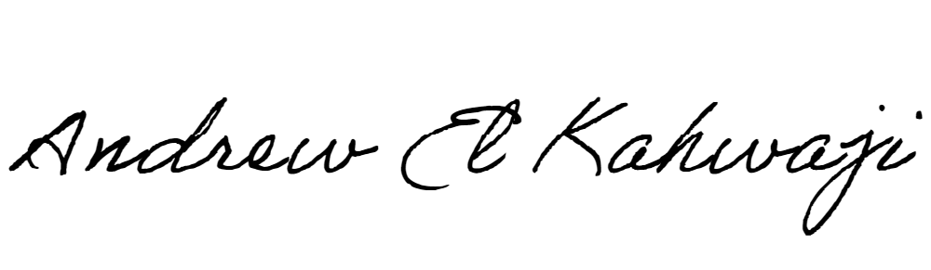

Printed Name _Andrew El Kahwaji_

Date __26/12/2024___

Email __andrew.lifesculptor.coo@gmail.com __

Phone __+961 71 914 378__